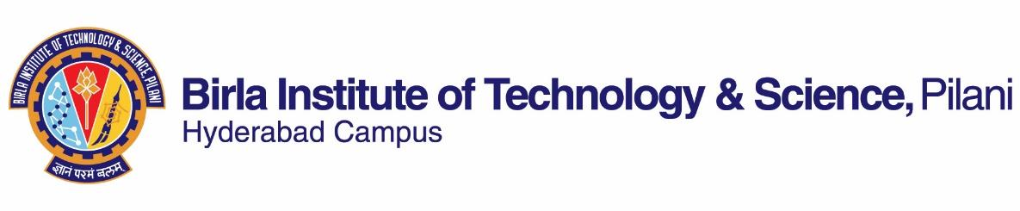

**SECOND SEMESTER 2019-2020**

# Course Handout Part II

Date: 06-01-2020

In addition to Part-I (General Handout for all courses appended to the time table) this portion gives further specific details regarding the course.

***Course No.* : GS F241**

## **Course Title : Creative Writing**

## **Instructor-in-Charge : Anhiti Patnaik**

***Research Assistant* : Jaya Sarkar**

**Scope of the Course:**

The objective of the course is to introduce students to the principles of creative writing, stimulating creative activity, and techniques of creating imagery. Students will learn how to construct plot, events, characters and write short stories, plays and poems, statements of purpose, critical essays on works of art. It will hone their ability to appreciate writing and creative production across genres, generate original ideas, as well as nurture their critical and communicative skills. The course will require from students a comprehensive report on the techniques learnt and include samples of their writing.

**Course Objectives:**

1. Develop creative ability through writing and editing.
2. Expand knowledge of writing tools and techniques.
3. Learn to compose in different genres of creative writing.
4. Define personal goals and methods as a writer.
5. Learn to critique a work of literature and understand constructive criticism.

**Text Book:**

Mills, Paul. *The Routledge Creative Writing Coursebook*. New York: Routledge, 2006.

**Reference Book:**

Morley, David. *The Cambridge Introduction to Creative Writing*. New York: CUP, 2007.

**Course Plan:**

|  |  |  |  |
| --- | --- | --- | --- |
| **Lecture No.** | **Learning Objectives** | **Topics to be covered** | **Reference Unit** |
| 1-3 | Distinguish between a story and a narrative | Introduction to course, Beginner’s Guide to Writing | Pg. 8-20, 37, 54, 90 |
| 4-7 | Cultivate voice, style, originality | Realism versus Romanticism | Pg. 1-10,  113-116,  99-102 |
| 8-9 | Connect with the reader | Empathy, Suspense | Lecture Notes |
| 10-12 | Comprehend major elements | Parts of a Plot | Pg. 163-169, 173 |
| 13-18 | Compare various narrative styles | Types of Narrators | Pg. 125-135, 155-158, 169-170 |
| 19-21 | Explore and classify traits of the short story | Fairy tale, Flash Fiction, Fragment | Chapter 5 |
| 22-25 | Explore and classify traits of the novel | Mystery, Romance, Sci-Fi, Fantasy | Chapter 4 |
| 26-27 | Explore and classify traits of poetry | Rhyme, Scansion, Styles, Free verse | Chapter 3 |
| 28-30 | Explore and classify traits of comics and graphic novels | Heroes versus Villains | Lecture notes |
| 31-33 | Learn video blogging | Dialogue, Niche, Perspective | Chapter 6 |
| 34-36 | Practice creative nonfiction | Diary, Personal Essay, Travelogue | Chapter 2 |
| 37-39 | Practice effective communication | Techniques of creating imagery- metaphor, simile, verisimilitude, defamiliarization | Lecture Notes |
| 40-41 | Critically evaluate examples of literature | The Death of Ivan Ilyich, The Nightingale and the Rose, The Highwayman, Milk and Honey | Lecture Notes |

**Evaluation Scheme:**

|  |  |  |  |  |
| --- | --- | --- | --- | --- |
| **Component** | **Duration** | **Weighting (%)** | **Date & Time** | **Nature of Component** |
| Writing Prompts | 60 mins | 30 | Saturdays in lecture  (Dates TBA on CMS a week before) | OB |
| Mid Term | 90 mins | 30 | 4/3/2020 9:00 AM | CB |
| Comprehensive Exam | 3 hrs | 40 | **July** | CB |

**Chamber Consultation Hour:** Wednesdays 11:00-12:00 pm, in Office K109

**Email:** anhitipatnaik@hyderabad.bits-pilani.ac.in

p20180439@hyderabad.bits-pilani.ac.in

**Notices:** Will be updated as and when on CMS portal.

**Make-up Policy:** Make-up for an evaluation component will be allowed only in genuine cases with prior permission or notice to the instructor. There will be no last-minute make-up examinations or late submissions. The decision of the instructor will be final.

**Academic Honesty and Integrity Policy:** Academic honesty and integrity are to be maintained by all the students throughout the semester and no type of academic dishonesty is acceptable. Plagiarism of any kind will result in a grade of 0 with no exceptions.

**Anhiti Patnaik**

**INSTRUCTOR-IN-CHARGE**